ATWARM
Advanced Technologies for Water Resource Management

Kick-off Meeting
11th May 2010
Queen’s University Belfast

ATWARM Partner Sites & Primary Supervisors
Queen’s University Belfast | QUB | Wilson McGarel  Michael Larkin  John McGrath  Stephen Allen | 
Dublin City University | DCU | Dermot Diamond  Fiona Regan  Anne Morrissey  John Tobin | 
Universitaet Duisburg-Essen | UDE | Michael Eisinger  Hans-Curt Flemming  Thorsten Mietzel | 
IWW Water Centre | IWW | Torsten Schmidt  Ursula Telgeder
Cranfield University | CRA | Raffaella Villa  Elise Cartmell | 
Northern Ireland Water | NIW | Sam Irwin  Charlie Pollock | 
T.E. Laboratories Ltd | TEL | Mark Bowkett  Breda Moore | 
*Bold text denotes Scientist-in-Charge at each site.

ATWARM Associated Partners

QUESTOR Member Companies (All) | 

ATWARM Budget – Maximum EC Contribution

Item | Details | Expected date of payment | Notes
Max EC Contribution | € 3,497,503.74 |  | *See note below
Advance payment | € 2,273,377.43 | QUB: End Feb10  Partners: Start May10 | QUB: 45 days after start date;  Partners: within 45 days of QUB payment.
Guarantee fund (5%) | € 174,875.19 | Apr14 | 5% retained by EC until end of project in case of partners reneging or other financial difficulties.
Interim payment | € 874,375.94 | Apr12 | 45 days after submission of periodic report. Amount transferred depends on spend in Period 1.
Final payment | € 349,750.37 | Apr14 | 45 days after submission of final report. Amount transferred depends on spend in Period 2.
*Marie Curie ITN budgets are calculated by the REA based on average projected costs of the Fellows due to be recruited.
The actual budget will vary from this predicted budget.

ATWARM Project List
Project, Fellow | Project Title | Supervisor | Measurable & Verifiable Objective
2.1, ESR | Non-thermal plasmas created by corona-like discharges for eliminating recalcitrant organic contaminants (IWW, UDE) | Torsten Schmidt | To demonstrate the operation of a non-thermal plasma reactor for the removal of organic contaminants from water and wastewater.
2.2, ESR | Development of novel integrated photocatalytic adsorbents (IPAs) for organics removal from water & wastewater (DCU) | John Tobin | To develop novel materials with dual absorbent and photocatalytic function.
2.3, ESR | Phosphorus removal & recovery from wastewater (QUB) | John McGrath | To investigate the physiological and biochemical basis of the novel stress induced phosphate uptake and polyphosphate accumulation by microorganisms.
2.4, ESR | Nutrient removal in wastewater using algae & fibre optics as a source of light (UDE) | Thorsten Mietzel | To test an innovative fibre-optic technology for light delivery enabling algal growth within a reactor.
2.5, ESR | Priority substances in activated sludge: incidence, accumulation, source tracking emitter identification & prevention strategies (UDE, IWW) | Hans-Curt Flemming | To deliver an improved understanding of the sorption and desorption properties of priority substances in sewage sludge and biofilms.
2.6, ESR | Integrated process for biogas production from algal biomass (CRA) | Raffaella Villa | To determine the influence of algal species on the performance of nutrient uptake and biogas production in the anaerobic digestion process.
2.7, ESR | Delivering low carbon anaerobic wastewater treatment and renewable energy production (CRA) | Elise Cartmell | To assess reactor stability and treatment effectiveness of the anaerobic digestion process – methane generation, effluent quality, nutrient removal and treatability, and removal of hazardous substances.
2.8, ER | Design and introduction of a carbon accounting system to Northern Ireland Water (NIW) | Sam Irwin | To provide a better understanding of the technicalities of carbon management in the water industry.
3.1, ESR | Fast on-site monitoring of gasoline-related compounds at contaminated sites using differential mobility spectrometry (IWW, UDE) | Torsten Schmidt | To incorporate microextraction methods for enrichment of target analytes into ion mobility spectrometry.
3.2, ESR | Development of rapid technologies for the assessment of biodegradation potential in contaminated groundwater using gene array technologies (QUB) | Mike Larkin | To develop an array for key biodegradative genes and trial data using test samples.
3.3, ER | To further develop and improve existing Total Petroleum Hydrocarbon (TPH) methods which can be validated to ISO17025 with improved detection limits in the range C9-C40 (TEL) | Mark Bowkett | To develop an improved method for TPH detection, with the ability to produce consistent reproducible results to a low detection limit.
3.4, ESR | Arsenic removal from water using dolomites and modified dolomites (QUB, DCU) | Stephen Allen | To investigate the mechanisms and kinetics for the removal of arsenic from industrial wastewaters by dolomite.
3.5, ESR | Long-term deployment of a faecal matter sensor in a marine & freshwater environment (DCU) | Fiona Regan | To assess the robustness in the field of an in situ fibre optic biosensor.
3.6, ESR | Assessment & usefulness of integrating stable isotope data and data on pharmaceuticals to disentangle point & diffuse sources of pollution (DCU, QUB) | Anne Morrissey | To investigate the origin and fate of nitrate in a complex multi-land use watershed.
3.7, ESR | Next generation autonomous analytical platforms for remote environmental monitoring. Project 1: Microfluidic platforms incorporating stimulus-responsive materials for Water Quality (DCU) | Dermot Diamond | To synthesise and characterise innovative biomimetic materials capable of actuation under photonic or electrochemical stimulation.
3.8, ESR | Next generation autonomous analytical platforms for remote environmental monitoring. Project 2: Generation of fully functioning biomimetic analytical platforms for Water Quality (DCU): | Dermot Diamond | To integrate photo-electro-actuators developed in project 3.7 into a microfluidic platform and demonstrate its application.

ATWARM - Gantt Chart
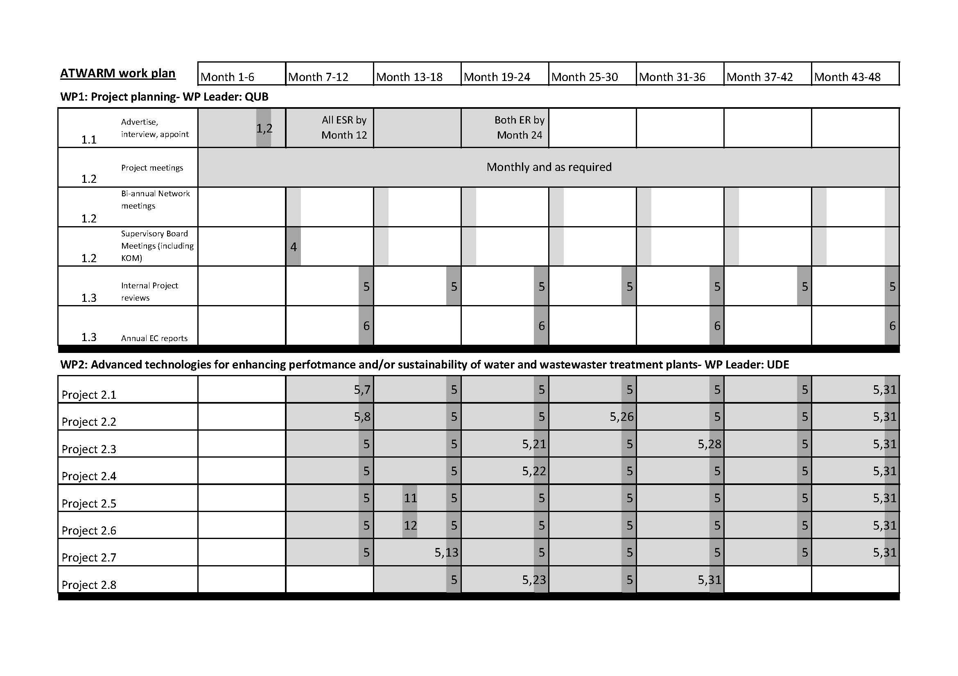
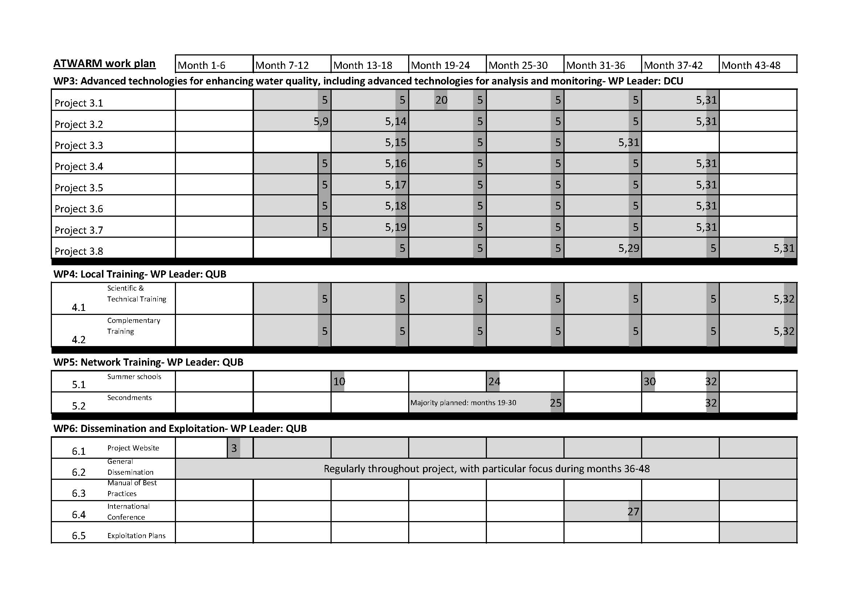

ATWARM Work Plan - Pert Chart
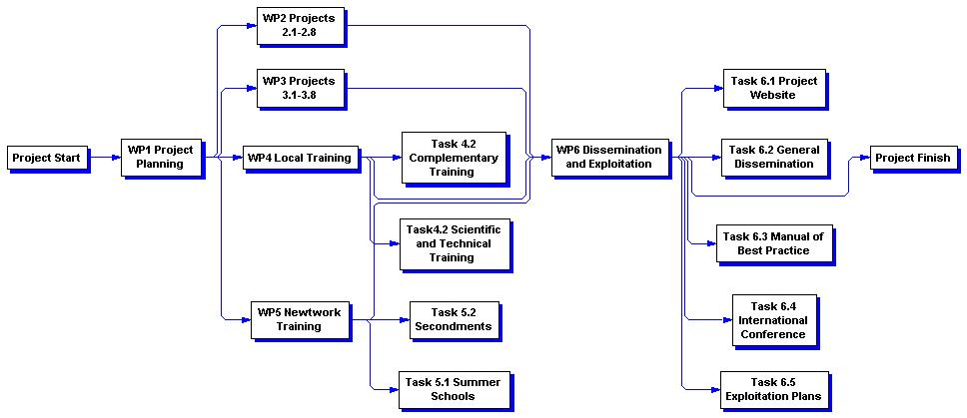
ATWARM - Project Milestones List
List and Schedule of Milestones

Milestone no. | Milestone name | WP no. | Lead beneficiary | Delivery date from Annex I | Comments
1 | Recruitment of ESRs | 1 | QUB | Apr10 – by Nov10 | This will ideally be completed as close to M5 as possible, but may take longer – up to M12, ESR; M24, ER – with input from all partners.
2 | Recruitment of ERs | 1 | QUB | Apr10 – by Nov11
3 | Project website established | 6 | QUB | Apr10
4 | ATWARM kick-off meeting | 1 | QUB | May10
5 | Submission of 6-monthly reviews to Supervisory Board | 1,2, 3, 4 | QUB | Nov10, May11, Nov11, May12, Nov12, May13, Nov13 | Submission of periodic progress review reports for all Fellows. Input from all partners.
6 | Annual review reports submitted to EC (progress, periodic & final report) | 1 | QUB | Nov10, Nov11, Nov12, Nov13 | Every 12 months from project start date. Input from all partners.
7 | Project 2.1: Selection of well-known references, problematic by-product precursors and ozone-recalcitrant components for testing | 2 | UDE | Apr11 | In association with IWW & UDE
8 | Project 2.2: Baseline adsorption studies complete | 2 | UDE | Apr11 | In association with DCU
9 | Project 3.2: Key target genes identified | 3 | DCU | Apr11 | In association with QUB
10 | Summer school 1 | 5 | QUB | Jul-Aug11 | In association with UDE & IWW
11 | Project 2.5: Decision point for specification of prototype monitor | 2 | UDE | Jun11 | In association with IWW
12 | Project 2.6: Algal species chosen | 2 | UDE | Feb11 | In association with CRA
13 | Project 2.7: Fortification conditions optimised | 2 | UDE | May11 | In association with CRA
14 | Project 3.2: Probe selection and design complete | 3 | DCU | Sept11 | In association with QUB
15 | Project 3.3: Criteria for industry standard identified | 3 | DCU | May11 | In association with TEL
16 | Project 3.4: Design criteria available for pilot scale unit construction | 3 | DCU | Oct11 | In association with QUB
17 | Project 3.5: Sensor deployed and operational with wireless communication at sites | 3 | DCU | Sept11 | In association with colleagues at DCU
18 | Project 3.6: Target pharmaceuticals and sites identified; sampling programme defined | 3 | DCU | Oct11 | In association with colleagues at DCU
19 | Project 3.7: Performance of synthesised polymer responsive materials meets criteria | 3 | DCU | Apr11 | In association with colleagues at DCU
20 | Project 3.1: Prototype ready for field testing | 3 | DCU | Jan12 | In association with IWW
21 | Project 2.3: Strains selected and identified | 2 | UDE | Apr12 | In association with QUB
22 | Project 2.4: Small scale experimental work complete | 2 | UDE | Apr12 | In association with colleagues at UDE
23 | Project 2.8: Systems and business processes design complete | 2 | UDE | Nov11 | In association with NIW
24 | Summer School 2 | 5 | QUB | Jun12 | In association with CRA & NIW
25 | Secondments concluded | 5 | QUB | Oct12 | Planned for Y2 of Fellow projects, but this is subject to change
26 | Project 2.2: Synthesis of IPAs complete | 2 | UDE | Oct12 | In association with DCU
27 | Conference programme and list of participants finalised | 6 | QUB | Oct12? Or Feb13? | Coordinated by DCU with input from other partners, QUB in particular
28 | Project 2.3: Phosphorus removal bioreactor studies complete | 2 | UDE | Apr13 | In association with QUB
29 | Project 3.8: Individual components functional and ready for integration | 3 | DCU | Sept12 | In association with colleagues at DCU
30 | Summer School 3 | 5 | QUB | Jul-Aug13 | In association with DCU & TEL
31 | Completion of Research Programme (WP2+3) | 2, 3 | UDE, DCU | M46 – Sept13 | End-date dependent upon recruitment issues
32 | Completion of Training Programme (WP4+5) | 4, 5 | QUB | M46 - Sept13 | End-date dependent upon recruitment issues

ATWARM – Project Deliverables List
DeliverableNumber | Deliverable name | WP | Lead Partner | Dissemination level | Deliverable notes & new delivery date regarding actual start date and changed start date (Oct 10)
D1 | Minutes of main meetings | 1 | QUB | RE* |  | May-10, Nov-10, May-11, Nov-11, May-12, Nov-12, May-13, Nov-13
D2 | Progress, Periodic and Final Reports | 1 | QUB | RE |  | Nov-10, May-11, Nov-11, May-12, Nov-12, May-13, Nov-13
D3 | Project 2.1 Deliverables | 2 | UDE
D3 – 2.1a | Project 2.1 Deliverables | 2 | UDE | RE | Test reactor set-up | Apr-11
D3 – 2.1b | Project 2.1 Deliverables | 2 | UDE | RE | Interim report | Apr-12
D3 – 2.1c | Project 2.1 Deliverables | 2 | UDE | RE | List of metabolites formed under typical operating conditions | Apr-13
D3 – 2.1d | Project 2.1 Deliverables | 2 | UDE | PU | Final Report | Sep-13
D4 | Project 2.2 Deliverables | 2 | UDE
D4 – 2.2a |  | 2 | UDE | RE | Benchmark report - effectiveness of activated carbons for oxidation product removal | Sep-11
D4 – 2.2b |  | 2 | UDE | RE | Interim report | Apr-12
D4 – 2.2c |  | 2 | UDE | RE | Demonstration of IPA application in on-site testing at industrial partner site | Sep-13
D4 – 2.2d |  | 2 | UDE | PU | Final Report | Sep-13
D5 | Project 2.3 Deliverables | 2 | UDE
D5 – 2.3a | Project 2.3 Deliverables | 2 | UDE | RE | Preliminary studies of effects of environmental & nutritional stress completed | Apr-11
D5 – 2.3b | Project 2.3 Deliverables | 2 | UDE | RE | Interim report | Apr-12
D5 – 2.3c | Project 2.3 Deliverables | 2 | UDE | RE | Biochemical & genetic characterisation of representative strains completed | Oct-12
D5 – 2.3d | Project 2.3 Deliverables | 2 | UDE | PU | Final Report | Sep-13
D6 | Project 2.4 Deliverables | 2 | UDE
D6 – 2.4a | Project 2.4 Deliverables | 2 | UDE | RE | Small-scale algae reactor | Apr-11
D6 – 2.4b | Project 2.4 Deliverables | 2 | UDE | RE | Interim report | Apr-12
D6 – 2.4c | Project 2.4 Deliverables | 2 | UDE | RE | Design & plan for set-up at large scale at a wastewater treatment plant | Apr-12
D6 – 2.4d | Project 2.4 Deliverables | 2 | UDE | PU | Final Report | Sep-13
D7 | Project 2.5 Deliverables | 2 | UDE
D7 – 2.5a | Project 2.5 Deliverables | 2 | UDE | RE | Reporting table on occurrence of priority substances in sewage sludge | Sep-11
D7 – 2.5b | Project 2.5 Deliverables | 2 | UDE | RE | Interim report | Apr-12
D7 – 2.5c | Project 2.5 Deliverables | 2 | UDE | RE | Prototype contamination monitor device | Jun-12
D7 – 2.5d | Project 2.5 Deliverables | 2 | UDE | PU | Final Report | Sep-13
DeliverableNumber | Deliverable name | WP | Lead Partner | Dissemination level | Deliverable notes & new delivery date regarding actual start date and changed start date (Oct 10)
D8 | Project 2.6 Deliverables | 2 | UDE
D8 – 2.6a | Project 2.6 Deliverables | 2 | UDE | RE | A design for an integrated algal growth & digestion process | May-11
D8 – 2.6b | Project 2.6 Deliverables | 2 | UDE | RE | Interim report | Oct-11
D8 – 2.6c | Project 2.6 Deliverables | 2 | UDE | RE | Assessment of the annual production of waste algae in different processes & potential biogas production under European specific conditions | May-13
D8 – 2.6d | Project 2.6 Deliverables | 2 | UDE | PU | Final Report | Jul-13
D9 | Project 2.7 Deliverables | 2 | UDE
D9 – 2.7a | Project 2.7 Deliverables | 2 | UDE | RE | Initial process design documentation | May-11
D9 – 2.7b | Project 2.7 Deliverables | 2 | UDE | RE | Interim report | Oct-11
D9 – 2.7d | Project 2.7 Deliverables | 2 | UDE | RE | Implementation guidance for anaerobic treatment for wastewater & wider waste effluents | Jul-13
D9 – 2.7c | Project 2.7 Deliverables | 2 | UDE | PU | Final Report | Jul-13
D10 | Project 2.8 Deliverables | 2 | UDE
D10 – 2.8a | Project 2.8 Deliverables | 2 | UDE | RE | Interim report | Nov-11
D10 – 2.8b | Project 2.8 Deliverables | 2 | UDE | RE | Benchmarking report - performance of designed systems | Nov-11
D10 – 2.8c | Project 2.8 Deliverables | 2 | UDE | PU | Final Report | Nov-12
D11 | Project 3.1 Deliverables | 3 | DCU
D11 – 3.1a | Project 3.1 Deliverables | 3 | DCU | RE | Prototype of miniaturised thermodesorption unit & test of SPME-IMS interface | Sep-11
D11 – 3.1b | Project 3.1 Deliverables | 3 | DCU | RE | Interim report | Apr-12
D11 – 3.1c | Project 3.1 Deliverables | 3 | DCU | RE | Standard protocol for analysis of gasoline-related contaminants using IMS | Sep-13
D11 – 3.1d | Project 3.1 Deliverables | 3 | DCU | PU | Final Report | Sep-13
D12 | Project 3.2 Deliverables | 3 | DCU
D12 – 3.2a | Project 3.2 Deliverables | 3 | DCU | RE | Interim report | Apr-12
D12 – 3.2b | Project 3.2 Deliverables | 3 | DCU | RE | Performance table for gene probes against samples & performance criteria | Apr-13
D12 – 3.2c | Project 3.2 Deliverables | 3 | DCU | RE | Gene microarray for key biodegradative genes | Sep-13
D12 – 3.2d | Project 3.2 Deliverables | 3 | DCU | PU | Final Report | Sep-13
D13 | Project 3.3 Deliverables | 3 | DCU
D13 – 3.3a | Project 3.3 Deliverables | 3 | DCU | RE | Extraction method | May-11
D13 – 3.3b | Project 3.3 Deliverables | 3 | DCU | RE | Interim report | Nov-11
D13 – 3.3c | Project 3.3 Deliverables | 3 | DCU | RE | Optimised SOP method for extraction and GC detection | Nov-12
D13 – 3.3d | Project 3.3 Deliverables | 3 | DCU | PU | Final Report | Nov-12
DeliverableNumber | Deliverable name | WP | Lead Partner | Dissemination level | Deliverable notes & new delivery date regarding actual start date and changed start date (Oct 10)
D14 | Project 3.4 Deliverables | 3 | DCU
D14 – 3.4a | Project 3.4 Deliverables | 3 | DCU | RE | A pilot-scale adsorption unit for arsenic | Apr-12
D14 – 3.4b | Project 3.4 Deliverables | 3 | DCU | RE | Interim report | Apr-12
D14 – 3.4c | Project 3.4 Deliverables | 3 | DCU | RE | Design & operation criteria for adsorbers to treat contaminated waters | Sep-13
D14 – 3.4d | Project 3.4 Deliverables | 3 | DCU | PU | Final Report | Sep-13
D15 | Project 3.5 Deliverables | 3 | DCU
D15 – 3.5a | Project 3.5 Deliverables | 3 | DCU | RE | Summary of data from biosensor in laboratory performance | Sep-11
D15 – 3.5b | Project 3.5 Deliverables | 3 | DCU | RE | Interim report | Apr-12
D15 – 3.5c | Project 3.5 Deliverables | 3 | DCU | RE | Sample report of downloaded data | Sep-12
D15 – 3.5d | Project 3.5 Deliverables | 3 | DCU | PU | Final Report | Sep-13
D16 | Project 3.6 Deliverables | 3 | DCU
D16 – 3.6a | Project 3.6 Deliverables | 3 | DCU | RE | Methods developed | Oct-11
D16 – 3.6b | Project 3.6 Deliverables | 3 | DCU | RE | Interim report | Apr-12
D16 – 3.6c | Project 3.6 Deliverables | 3 | DCU | RE | Database of isotopic composition of nitrate in Irish water bodies | Jul-13
D16- 3.6d | Project 3.6 Deliverables | 3 | DCU | PU | Final Report | Sep-13
D17 | Project 3.7 Deliverables | 3 | DCU
D17 – 3.7a | Project 3.7 Deliverables | 3 | DCU | RE | Fluidic platforms fabricated | Nov-10
D17 – 3.7b | Project 3.7 Deliverables | 3 | DCU | RE | Interim report | Nov-11
D17 – 3.7c | Project 3.7 Deliverables | 3 | DCU | RE | Demonstration of functioning analytical platform | Apr-13
D17 – 3.7d | Project 3.7 Deliverables | 3 | DCU | PU | Final Report | Apr-13
D18 | Project 3.8 Deliverables | 3 | DCU
D18 – 3.8a | Project 3.8 Deliverables | 3 | DCU | RE | Successful integration of biomimetic structures with detectors | Sep-11
D18 – 3.8b | Project 3.8 Deliverables | 3 | DCU | RE | Interim report | Feb-12
D18 – 3.8c | Project 3.8 Deliverables | 3 | DCU | RE | Demonstration of functioning analytical platform | Sep-13
D18 – 3.8 | Project 3.8 Deliverables | 3 | DCU | PU | Final Report | Sep-13
D19 | Declarations on Conformity | 1 | QUB | RE | Immediately upon appointment of researchers
D20 | Proceedings of 3 summer schools | 5 | QUB | PU | Assume moving Summer Schools to Jul-Aug each year | Sep-11; Sep-12; Sep-13
D21 | Reports on secondment periods | 5 | QUB | PP | Secondments during Y2 of Fellow appointment – report by end of project Y2
 |  |  |  |  |  | Sep-12
D22 | Proceeedings of the short international conference on Advances in Water Resource Management | 6 | QUB | PU |  | May-13
DeliverableNumber | Deliverable name | WP | Lead Partner | Dissemination level | Deliverable notes & new delivery date regarding actual start date and changed start date (Oct 10)
D23 | Project website (to be periodically updated) | 6 | QUB | PU |  | Apr-10 to Nov-13
D24 | Manual of Best Practice Produced | 6 | QUB | PU |  | Nov-13
D25 | Questionnaire | 1 | QUB | CO | At middle, end & 2 years after each Fellow’s research project | Apr-11, Sep-13, Sep-15
D26 | Final Plan for the Use and Dissemination of Foreground – including main dissemination material | 6 | QUB | PU |  | Nov-13
D27 | Report on awareness and wider societal implications of the project | 6 | QUB | PU |  | Nov-13
D28 | Scientific training material | 4 | QUB | PU |  | Sep-11, Sep-12, Sep-13, Nov-13
D29 | Complementary training material | 4 | QUB | PU |  | Sep-11, Sep-12, Sep-13, Nov-13
D30 | Exploitation plans for projects with potential for commercialisation | 6 | QUB | PP |  | Nov-13

